AI Document Control Assistant
Week 13 Technical Documentation
Prepared for Cubic Engineering Consultancy. This document describes the integrated platform architecture, workflow, API, analytics, evaluation approach, and demonstration procedure.

1. Executive Summary
The Week 13 platform consolidates document intake, AI-assisted metadata extraction, classification, workflow control, audit trail, analytics, and reporting into one deployable FastAPI web application. The system provides a dashboard, document register, REST API, demo data, tests, technical documentation, and a final presentation.

2. Architecture
The platform uses clear service boundaries so previously developed modules can be integrated or replaced behind stable interfaces.
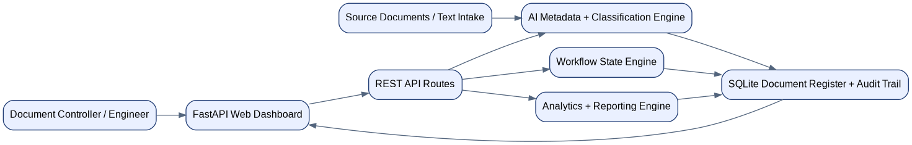

3. Integrated Components
Component | Purpose
FastAPI dashboard | Document register, upload flow, detail page, workflow actions
REST API | Integration endpoints for documents, audit trail, and analytics
AI engine | Metadata extraction, discipline classification, document type classification, confidence, and risk score
Workflow service | Validates lifecycle state transitions and records audit events
Analytics service | Reports status, discipline, type, confidence, risk, and overdue KPIs
SQLite database | Stores document register records and audit events

4. Workflow States
The controlled lifecycle is Draft -> In Review -> Approved -> Issued -> Archived. Alternative routes allow Draft -> Archived, In Review -> Rejected -> Draft, and Approved -> Archived.

5. API Summary
Method | Endpoint | Description
GET | /api/documents | Return document register
GET | /api/documents/{id} | Return one document
POST | /api/documents/{id}/transition | Apply workflow transition
GET | /api/documents/{id}/audit | Return audit trail
GET | /api/analytics/summary | Return KPI summary

6. Accuracy and Performance
The included evaluation script uses five labeled demo cases. The current explainable rule-based classifier returns 100% discipline accuracy and 100% document-type accuracy on the included dataset. The report clearly marks this as demo-scope validation, not production validation.

7. Test Results
Automated verification passed: 4 tests passed. The tests cover AI classification, metadata extraction, valid workflow transitions, and invalid workflow blocking.

8. Run Commands
pip install -r requirements.txt
python scripts/seed_demo.py
uvicorn app.main:app --reload
pytest -q
python scripts/evaluate_ai.py

9. Production Enhancement Plan
- Replace SQLite with PostgreSQL for multi-user deployment.
- Add authentication and role-based approvals.
- Add OCR and PDF parsing for scanned documents.
- Add object storage for controlled source files.
- Add notifications for overdue reviews and rejected documents.
- Measure precision, recall, F1 score, latency, and reviewer correction rate on real project records.

